How to commit a new folder location to an existing Gitlab Repository.

These instructions will show you how to push a local project, saved on your computer, to a project that you have maintainer rights to.

First set up your project, here I am using the “Data Collection Upload Assistant”

Link <https://gitlab.gda.allianz/> on VPN, crowd credentials

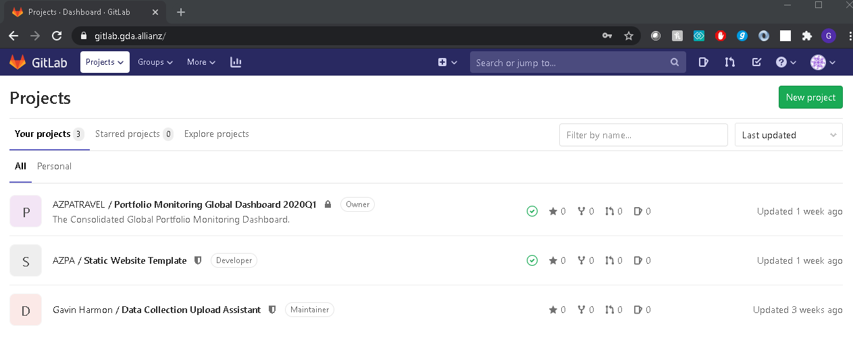

Customized version of documents available here: <https://docs.gitlab.com/ee/university/training/topics/getting_started.html> [Disconnect from US VPN]

First navigate in a terminal to the top folder you would like to push to the GitLab Page:

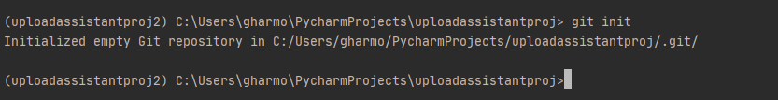

$git init

This writes a folder that governs the connection to Gitlab, open the “config” file

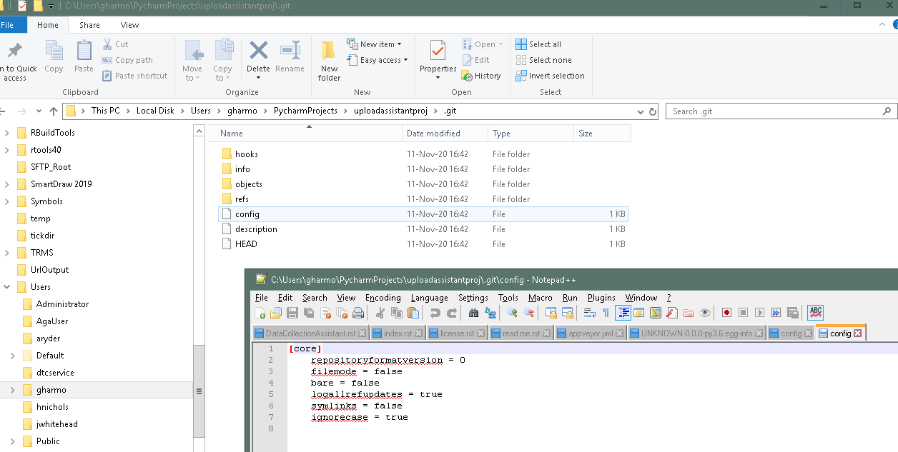

Append this snippet to the config contents:

============================

[remote "origin"]

url = [my url]

fetch = +refs/heads/\*:refs/remotes/origin/\*

[branch "master"]

remote = origin

merge = refs/heads/master

============================

Replace [my url] with the address of the GitLab project page (shown below)

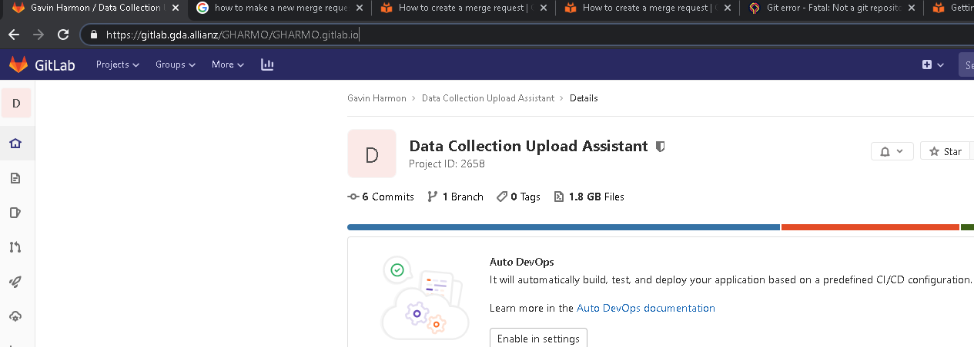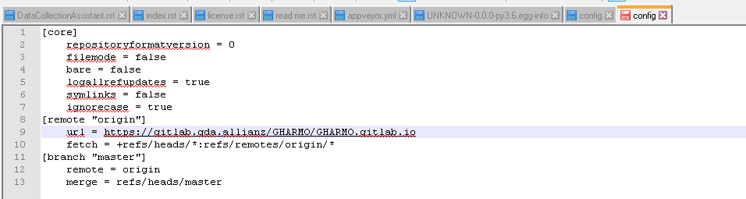

$git status

Ensure you do not get an error

$git diff

Find changes (if this is a first commit you will have none [no comparison])

$git add \*

Gather all the files, after this you will want to only commit changed files.

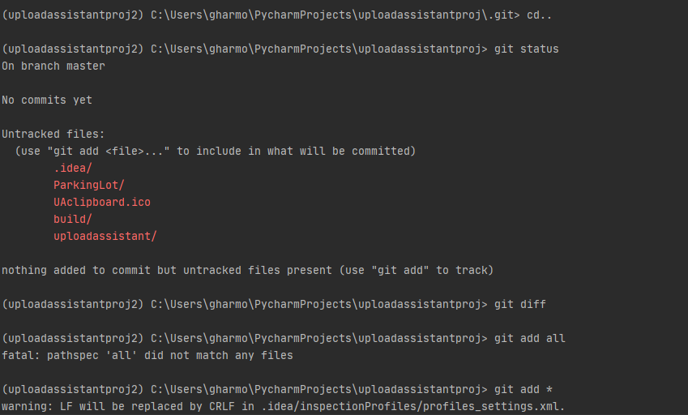

$git commit –m ‘a-description-of-the-version’

Prepare and add a comment

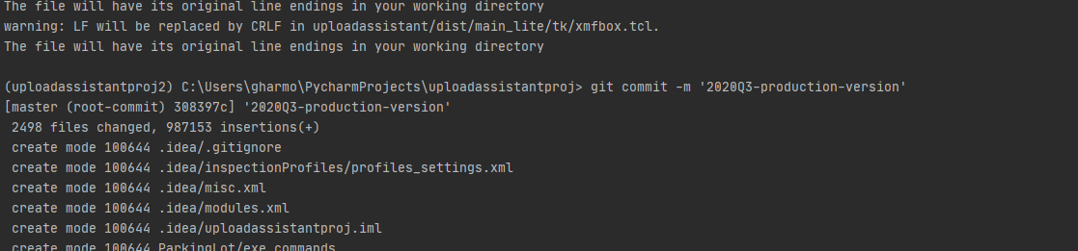

$git push origin master (--force)

Load the commit (you will overwrite anything that is currently in the repository

Note: you may be prompted for credentials. Be careful and do not guess. It will be painful to edit credentials. You may get around this by ensuring you can signed into GitLab.

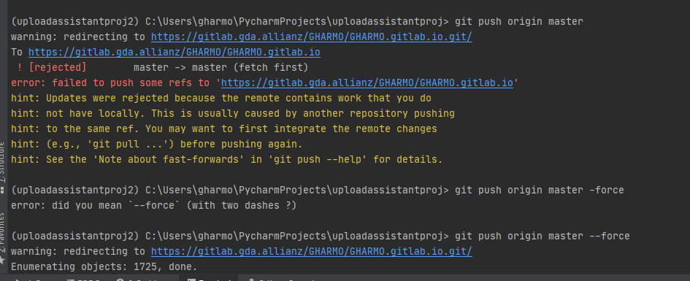

Follow the final link in the terminal and review your new repository.

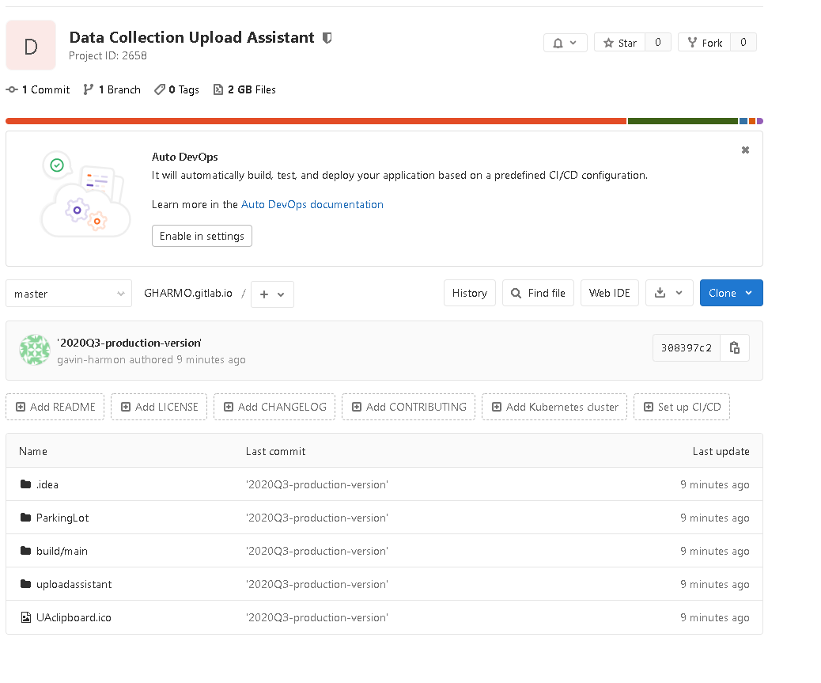

Further documentation

<https://docs.gitlab.com/ee/user/project/merge_requests/creating_merge_requests.html#new-merge-request-from-a-new-branch-created-through-the-ui> [Disconnect from US VPN]